Epsom & Ewell F.C.
2
v
Chipstead F.C.
Tuesday, 4th August 2015
Good evening! It may be hard to believe but he we are, commemorating Dave Wilson’s memory for the ninth time! After a break of three seasons we thank Chipstead for agreeing to be our opponents and the use of their ground for this prestigious fixture in our calendar.

As we approach the start of our fourth season ground sharing with our near neighbours, it is easy to forget that they were of course the final side to ever play us at West Street, back on 6th May 1993. Arguably they were as uncertain times as the ones we face today, but rest assured that we are still looking for a ground back in the Borough and still have a number of options, even twenty two years on from our departure.

We have picked up quite a few new supporters in recent years, and some of them will not have had the great benefit of knowing our former Secretary in whose name this tournament is commemorated. So just to recap, Dave Wilson held a number of positions during the 35 years that he was connected with the club and worked tirelessly towards its benefit. I have no doubt that he would still be watching now had he not been taken from us nearly nine years ago now at the early age of 56.

This is obviously a very sad situation, although I think that credit goes to our club for managing to keep this tournament running, despite the absence of a home ground and one day we hope that we will be able to revert to the original four team format, or maybe with even more teams involved.

As with previous Dave Wilson Trophy programmes, I will take the opportunity to round up last season and to let you know what has happened so far during the early days of 2015/16. Also, on Saturday we meet Windsor in our opening League match so please come down and support our club. The invite also stands for any Chipstead supporters who don’t fancy the long trip to Hastings United! The following weekend we have a double header at High Road as Chipstead host Herne Bay on the Saturday while we host Erith & Belvedere on the Sunday in the F.A. Cup. You’re more than welcome!

Finally, I would like to thank our Kit Sponsors Intercem, who have provided a further donation for this season and we now have their logo on the front of both our blue and yellow kits! We are grateful for any forms of sponsorship and if you can help, just let us know.

Rich
Did you know we are now on Facebook? www.facebook.com/epsomandewellfc
And we are still on Twitter @EEFCOfficial

Cover photo

It’s November 1989 and Dave Wilson celebrates his 40th birthday in the club house at our old ground. But can you name the other six people in the picture?
The answer is at the back of the programme.

Cherry Red Records
Combined Counties League
Premier Division Final Table 2014/15
 | P | W | D | L | F | A | Pts | GD | H | A
Molesey | 40 | 30 | 1 | 9 | 108 | 36 | 91 | +72 | 1-3 | 0-5
Camberley Town | 40 | 26 | 8 | 6 | 86 | 33 | 86 | +53 | 2-4 | 0-1
Ashford Town (Mx) | 40 | 25 | 5 | 10 | 94 | 54 | 80 | +40 | 2-4 | 3-1
Cove | 40 | 23 | 8 | 9 | 89 | 65 | 77 | +24 | 2-2 | 0-1
Windsor | 40 | 23 | 4 | 13 | 96 | 57 | 73 | +39 | 0-5 | 3-0
Spelthorne Sports | 40 | 20 | 6 | 14 | 73 | 60 | 66 | +13 | 4-3 | 3-0
Epsom & Ewell | 40 | 19 | 4 | 17 | 77 | 68 | 61 | +9 | - | -
Badshot Lea | 40 | 18 | 5 | 17 | 74 | 58 | 59 | +16 | 3-0 | 2-4
Hartley Wintney | 40 | 16 | 5 | 19 | 56 | 77 | 53 | -21 | 2-1 | 1-2
Farnham Town | 40 | 15 | 7 | 18 | 77 | 99 | 52 | -22 | 2-4 | 2-0
Colliers Wood United | 40 | 15 | 6 | 19 | 75 | 71 | 51 | +4 | 2-1 | 2-3
Horley Town | 40 | 13 | 9 | 18 | 70 | 88 | 48 | -18 | 2-2 | 0-1
Knaphill | 40 | 14 | 6 | 20 | 58 | 81 | 48 | -23 | 1-2 | 4-1
Westfield | 40 | 12 | 11 | 17 | 61 | 68 | 47 | -7 | 3-1 | 0-4
Raynes Park Vale | 40 | 13 | 8 | 19 | 50 | 65 | 47 | -15 | 0-1 | 2-0
Bedfont Sports | 40 | 14 | 5 | 21 | 52 | 74 | 47 | -22 | 0-1 | 2-0
Guildford City | 40 | 14 | 4 | 22 | 76 | 100 | 46 | -24 | 4-1 | 3-1
Mole Valley SCR | 40 | 13 | 6 | 21 | 62 | 94 | 45 | -32 | 1-0 | 5-2
Hanworth Villa | 40 | 12 | 8 | 20 | 58 | 73 | 44 | -15 | 1-1 | 5-2
Chertsey Town | 40 | 12 | 7 | 21 | 66 | 94 | 43 | -28 | 1-2 | 2-1
Frimley Green | 40 | 9 | 5 | 26 | 60 | 103 | 32 | -43 | 0-0 | 5-1

During the summer, Molesey have been promoted to the Ryman League, while Frimley Green have been relegated to Division One of our League.

In their place we have received Redhill from the Ryman League and AFC Hayes (formerly Brook House when we last played them) from the Southern League.

Additionally, Chessington & Hook United have bounced straight back after their relegation the previous season so we are now back up to a full complement of 22 teams for 2015/16.

Cup Draws for 2015/16
We face a real challenge in both the F.A.Cup and F.A.Vase this season.

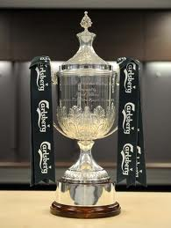
In the F.A.Cup we host Erith & Belvedere on Sunday 16th August. This is a very tough draw against a Southern Counties East (formerly Kent) League team that have recently been in the Ryman League and are keen to return there. They also reached the Quarter-Finals of the F.A. Vase last season, losing narrowly 2-0 to the eventual winners North Shields so we will have to be at our very best to get anything from this match. Should we progress though, the prize is a significant one as we would host our local friends Carshalton Athletic and with that game also having to take place on a Sunday it could provide our biggest attendance for many years.

Although we have played the Deres on 42 previous occasions dating back to the London League in 1929, we have never met in the F.A. Cup. We have met the Robins on 73 occasions with only Camberley Town having played us more, but have only met twice in the F.A. Cup, in 1934 and in 1960 with one win apiece. We last met in 2007 for a Surrey Senior Cup tie, but have not actually beaten them since 1955 which was 17 meetings ago!

In the F.A.Vase we face a trip to Sussex where we meet another team that lost their ground in Horsham. Recently relegated from the Ryman League this will be their first Vase tie since the late nineties and although we have met on 55 occasions dating back to 1957 we have never met in this competition. As with Erith I am sure they will be looking to bounce straight back, although they were relegated to Step Five for a reason and their attempts to find a new ground following the sale of the Queen Street ground around ten years ago have proven as frustrating as ours. The game will be played at Horsham YMCA’s Gorings Mead ground on Sunday 6th September.

If we defeat them we will face a trip to the scene of a daylight robbery from 2009, the High Street Ground, Selsey. We travelled down there in the F.A. Cup, yet despite their keeper being sent off after just 11 minutes and our domination of the game, they scored with a wind assisted long range deflected fluke goal. I’m not bitter, honest!

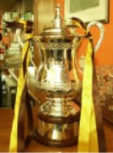
For some reason less rounds have been drawn in advance in both competitions this year, so we do not know who our opponents would be if we were to win two matches in either competition, but we’ll worry about that if it happens!
In the Surrey Senior Cup we do not yet know our opponents. Last season they did the draws live on BBC Radio Surrey and I hope they will do this again. Watch this space!

Finally, In the League Cup we have a bye to the Second round (last 32) where we have a local journey to our old stomping ground of Merland Rise to face Banstead Athletic. As always, this competition represents our best chance of progress.

All in all, an interesting set of ties and an opportunity for progress if we can play well.

During the Break
Our Club Presentation took place on the Saturday 25th April at the Epsom Working Mens Club and it was a good day for Kyle Hough who picked up the Player of the Year Trophy, the Players Player of the Year Trophy and an award for reaching 300 appearances.

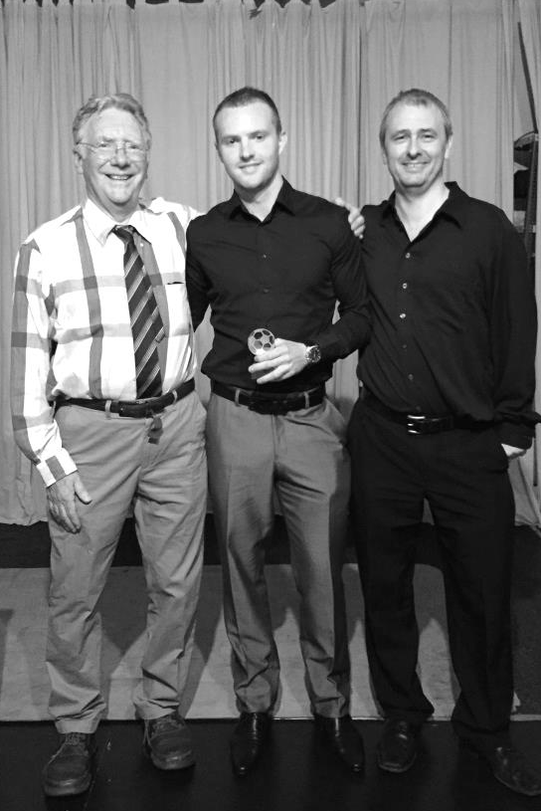
Additionally, James Taylor won the Managers Player of the Year Trophy, while Paul Marshall received the Clubman of the Year Trophy. Full pictures are available on the website, courtesy of Alex McKay.

Before you had time to rest we were back into pre-season, although many clubs started earlier and it will be interesting to see how well some of those clubs get on as the season stretches on.

We opened up our friendly schedule with a 2-2 draw against Banstead Athletic with Kyle Hough scoring twice and followed this with a 2-0 win over Sussex League Broadbridge Heath where the scorers were Savva ‘Agi’ Panayiotou and James Kavanagh.

The third of our four matches at Surbiton Town was against Hoddesdon Town; our opponents 40 years ago in the Final of the F.A. Vase but this time with a different result as we defeated our Hertfordshire opponents 5-3, with two late goals for the visitors. Kyle scored another four with Matt Farrell scoring the fifth goal.

We then had to cancel our trip to St Francis Rangers on Saturday 25th July, but three days later we hosted Lingfield at Surbiton Town and gained a small measure of revenge for our Vase defeat last season with a 4-0 win. This time we had four different scorers and Dan Dean, Kyle Hough, Matt Farrell and Reisse Griffin found the net.

Finally, on Saturday we visited the Croydon Arena for a friendly with Croydon and with only eleven players fell to a 2-0 defeat after being goalless at half time.

Which brings us to tonight’s game, our final pre-season friendly and arguably our toughest.

First Team Fixtures - 2015/16 (HOME GAMES IN CAPITALS)
08/08/15 | Sat | WINDSOR | CCL | 08/12/15 | Tue | COVE | CCL
11/08/15 | Tue | Redhill | CCL | 12/12/15 | Sat | Badshot Lea | CCL
16/08/15 | Sun | ERITH & BELVEDERE | FAC  Ex Pr | 19/12/15 | Sat | SUTTON COMMON ROVERS | CCL
18/08/15 | Tue | COLLIERS WOOD UNITED | CCL | 28/12/15 | Mon | Horley Town | CCL
22/08/15 | Sat | Sutton Common Rovers | CCL | 02/01/16 | Sat | REDHILL | CCL
29/08/15 | Sat | Westfield OR | CCL | 09/01/16 | Sat | AFC Hayes | CCL
30/08/15 | Sun | CARSHALTON ATHLETIC | FAC PR | 16/01/16 | Sat | SPELTHORNE SPORTS | CCL
31/08/15 | Mon | RAYNES PARK VALE OR | CCL | 23/01/16 | Sat | Windsor | CCL
01/09/15 | Tue | RAYNES PARK VALE | CCL | 30/01/16 | Sat | HARTLEY WINTNEY | CCL
06/09/15 | Sun | Horsham  (at Horsham YMCA) | FAV 1q | 06/02/16 | Sat | Farnham Town | CCL
12/09/15 | Sat | Spelthorne Sports | CCL | 13/02/16 | Sat | BEDFONT SPORTS | CCL
19/09/15 | Sat | AFC HAYES | CCL | 20/02/16 | Sat | Camberley Town | CCL
26/09/15 | Sat | FARNHAM TOWN | CCL | 27/02/16 | Sat | HORLEY TOWN | CCL
03/10/15 | Sat | Selsey OR | FAV 2q | 05/03/16 | Sat | Chertsey Town | CCL
03/10/15 | Sat | Cove | CCL | 12/03/16 | Sat | KNAPHILL | CCL
10/10/15 | Sat | Hartley Wintney | CCL | 19/03/16 | Sat | Chessington & Hook United | CCL
13/10/15 | Tue | Banstead Athletic | CCLC 2 | 26/03/16 | Sat | WESTFIELD | CCL
17/10/15 | Sat | CHERTSEY TOWN | CCL | 28/03/16 | Mon | Raynes Park Vale | CCL
24/10/15 | Sat | Ashford Town (Mx) | CCL | 02/04/16 | Sat | Guildford City | CCL
31/10/15 | Sat | Bedfont Sports | CCL | 09/04/16 | Sat | BADSHOT LEA | CCL
07/11/15 | Sat | CHESSINGTON & HOOK UNITED | CCL | 16/04/16 | Sat | CAMBERLEY TOWN | CCL
14/11/15 | Sat | Knaphill | CCL | 23/04/16 | Sat | Hanworth Villa | CCL
21/11/15 | Sat | HANWORTH VILLA | CCL | 30/04/16 | Sat | ASHFORD TOWN (MX) | CCL
28/11/15 | Sat | Colliers Wood United | CCL
05/12/15 | Sat | GUILDFORD CITY | CCL | tba |  |  | SSC

Early League Fixtures
Combined Counties League – Friday 7th August
Sutton Common Rovers | V | Colliers Wood United
Combined Counties League – Saturday 8th August
Ashford Town (Mx) | V | AFC Hayes
Bedfont Sports | V | Knaphill
Camberley Town | V | Horley Town
Chertsey Town | V | Guildford City
Epsom & Ewell | V | Windsor
Farnham Town | V | Chessington & Hook United
Hanworth Villa | V | Badshot Lea
Hartley Wintney | V | Redhill
Raynes Park Vale | V | Cove
Westfield | V | Spelthorne Sports
Combined Counties League – Monday 10th August
Sutton Common Rovers | V | Raynes Park Vale
Combined Counties League – Tuesday 11th August
AFC Hayes | V | Hanworth Villa
Badshot Lea | V | Hartley Wintney
Chessington & Hook United | V | Ashford Town (Mx)
Horley Town | V | Knaphill
Redhill | V | Epsom & Ewell
Spelthorne Sports | V | Camberley Town
Windsor | V | Bedfont Sports
Combined Counties League – Wednesday 12th August
Colliers Wood United | V | Chertsey Town
Cove | V | Westfield
Guildford City | v | Farnham Town
F.A. Cup Extra – Preliminary Round – Saturday 15th August
AFC Hayes | V | Flackwell Heath
Arundel | V | Raynes Park Vale
Badshot Lea | V | Camberley Town
Berkhamsted | V | Hanworth Villa
Binfield | V | Westfield
Chessington & Hook United | V | Crowborough Athletic
Chinnor | V | Hartley Wintney
Colliers Wood United | V | Eastbourne Town
Cove | V | Shrivenham
Recent Results / Fixtures
F.A. Cup Extra – Preliminary Round – Saturday 15th August
Croydon | V | Sutton Common Rovers
Horley Town | V | Wick & Barnham United
Knaphill | V | Highworth Town
Potton United | V | Bedfont Sports
Reading Town | V | Chertsey Town
Redhill | V | Pagham
Spelthorne Sports | V | Stotfold
Tadley Calleva | V | Guildford City
Thame United | V | Farnham Town
Wellingborough Town | V | Ashford Town (Mx)
Windsor | V | AFC Dunstable
F.A. Cup Extra – Preliminary Round – Sunday 16th August
Epsom & Ewell | V | Erith & Belvedere
Combined Counties League – Tuesday 18th August
Ashford Town (Mx) | V | Spelthorne Sports
Bedfont Sports | V | Sutton Common Rovers
Camberley Town | V | Cove
Chertsey Town | V | Horley Town
Epsom & Ewell | V | Colliers Wood United
Farnham Town | V | Badshot Lea
Hanworth Villa | V | Windsor
Hartley Wintney | V | Guildford City
Knaphill | V | Redhill
Raynes Park Vale | V | Chessington & Hook United
Westfield | V | AFC Hayes
Combined Counties League – Saturday 22nd April
AFC Hayes | V | Knaphill
Bedfont Sports | V | Raynes Park Vale
Chessington & Hook United | V | Chertsey Town
Colliers Wood United | V | Hartley Wintney
Cove | V | Ashford Town (Mx)
Guildford City | V | Westfield
Horley Town | V | Hanworth Villa
Redhill | V | Camberley Town
Spelthorne Sports | V | Farnham Town
Sutton Common Rovers | V | Epsom & Ewell
Windsor | V | Badshot Lea

Centre page for results

Centre page for results

First Eleven Appearances - (max 49)
Name | Debut | 2014/15 |  |  |  | Career Totals
 |  | App | Sub | Total | Goals | App | Sub | Total | Goals
BROWN Oshane | 30/08/2014 | 2 | 0 | 2 | 0 | 2 | 0 | 2 | 0
BURNS Robbie | 14/08/2007 | 3 | 2 | 5 | 0 | 205 | 16 | 221 | 121
COOPER-SMITH Daryl | 03/01/2015 | 9 | 3 | 12 | 6 | 9 | 3 | 12 | 6
CURRIE Sam | 04/08/2012 | 14 | 4 | 18 | 0 | 108 | 9 | 117 | 2
DEAN Dan | 02/08/2014 | 36 | 1 | 37 | 0 | 36 | 1 | 37 | 0
DEWAR Ali | 29/10/2011 | 5 | 6 | 11 | 3 | 55 | 35 | 90 | 10
DOUGLIN Karl | 03/08/2013 | 1 | 0 | 1 | 1 | 41 | 3 | 44 | 14
DOWNS Carl | 17/09/2011 | 4 | 1 | 5 | 0 | 94 | 13 | 107 | 2
EACOTT Michael | 02/08/2014 | 46 | 0 | 46 | 0 | 46 | 0 | 46 | 0
FARRELL Matt | 02/08/2014 | 41 | 3 | 44 | 7 | 41 | 3 | 44 | 7
FERDINANDO Matt | 20/09/2014 | 27 | 4 | 31 | 6 | 27 | 4 | 31 | 6
FRANKLIN Ben | 03/03/2015 | 1 | 0 | 1 | 0 | 1 | 0 | 1 | 0
GAFFNEY Luke | 16/08/2014 | 10 | 1 | 11 | 0 | 10 | 1 | 11 | 0
GANNON Thomas | 28/03/2015 | 0 | 1 | 1 | 0 | 0 | 1 | 1 | 0
HARPER Tommy | 15/04/2014 | 1 | 0 | 1 | 0 | 2 | 1 | 3 | 0
HAYWARD Ben | 07/03/2007 | 7 | 0 | 7 | 0 | 243 | 28 | 271 | 18
HOADLEY Harry | 27/08/2011 | 6 | 2 | 8 | 0 | 7 | 2 | 9 | 0
HOUGH Kyle | 14/08/2007 | 42 | 3 | 45 | 34 | 296 | 15 | 311 | 171
JARMAN Mark | 08/08/2009 | 5 | 5 | 10 | 0 | 136 | 51 | 187 | 76
KAVANAGH James | 04/04/2015 | 0 | 4 | 4 | 0 | 0 | 4 | 4 | 0
MARVELL Dale | 15/01/2000 | 0 | 4 | 4 | 0 | 0 | 4 | 4 | 0
MCGREGOR Alex | 08/08/2009 | 11 | 5 | 16 | 5 | 261 | 45 | 306 | 85
MCKAY Alex | 20/12/2008 | 15 | 2 | 17 | 1 | 172 | 56 | 228 | 27
MURPHY George | 28/03/2013 | 20 | 4 | 24 | 1 | 85 | 26 | 111 | 8
MUTIMA Lionel | 05/08/2014 | 25 | 2 | 27 | 1 | 66 | 6 | 72 | 3
NELMES Elliott | 05/08/2014 | 4 | 2 | 6 | 0 | 4 | 2 | 6 | 0
PANAYI Anthony | 14/11/2010 | 2 | 0 | 2 | 0 | 2 | 0 | 2 | 0
PANAYIOUTOU Savva | 03/01/2015 | 40 | 2 | 42 | 0 | 167 | 16 | 183 | 4
ROBINSON Matt | 01/12/2012 | 16 | 3 | 19 | 3 | 16 | 3 | 19 | 3
ROBINSON Sam | 22/10/2011 | 20 | 2 | 22 | 4 | 21 | 5 | 26 | 5
ROWE Steve | 27/08/2011 | 30 | 1 | 31 | 8 | 54 | 4 | 58 | 13
SHAW Ollie | 20/09/2014 | 19 | 1 | 20 | 0 | 24 | 2 | 26 | 0
SMITH Matt | 08/08/2009 | 0 | 10 | 10 | 0 | 0 | 10 | 10 | 0
SMITH Taylor | 02/08/2014 | 0 | 1 | 1 | 0 | 91 | 43 | 134 | 10
TANTON Matt | 02/08/2014 | 13 | 2 | 15 | 7 | 13 | 2 | 15 | 7
TAYLOR James | 26/08/2013 | 18 | 4 | 22 | 1 | 18 | 4 | 22 | 1
VAN GELDER Julian | 12/09/2006 | 39 | 2 | 41 | 2 | 56 | 8 | 64 | 3
WHITE Sean | 02/08/2014 | 0 | 1 | 1 | 0 | 0 | 2 | 2 | 0
YOUNG Conor Jack | 07/03/2015 | 6 | 13 | 19 | 3 | 6 | 13 | 19 | 3
Own Goal |  |  |  |  | 1

Ryman League Division One South - Final Table
 | P | W | D | L | F | A | Pts | GD
Burgess Hill Town | 44 | 32 | 9 | 3 | 99 | 38 | 105 | +61
Faversham Town | 44 | 29 | 7 | 8 | 105 | 49 | 94 | +56
Folkestone Invicta | 44 | 28 | 10 | 6 | 102 | 46 | 94 | +56
Merstham | 44 | 25 | 12 | 7 | 101 | 50 | 87 | +51
Whyteleafe | 44 | 23 | 12 | 9 | 91 | 58 | 81 | +33
Worthing | 44 | 21 | 10 | 13 | 88 | 60 | 73 | +28
Three Bridges | 44 | 20 | 9 | 15 | 91 | 91 | 69 | 0
Whitstable Town | 44 | 19 | 11 | 14 | 80 | 71 | 68 | +9
Herne Bay | 44 | 19 | 8 | 17 | 60 | 64 | 65 | -4
Guernsey | 44 | 18 | 6 | 20 | 86 | 91 | 60 | -5
Sittingbourne | 44 | 15 | 11 | 18 | 52 | 66 | 56 | -14
Corinthian-Casuals | 44 | 16 | 8 | 20 | 61 | 79 | 56 | -18
South Park | 44 | 16 | 7 | 21 | 74 | 101 | 55 | -27
Hythe Town | 44 | 14 | 11 | 19 | 78 | 73 | 53 | +5
Tooting & Mitcham Utd | 44 | 13 | 14 | 17 | 70 | 66 | 53 | +4
Walton Casuals | 44 | 16 | 5 | 23 | 61 | 85 | 53 | -24
Walton & Hersham | 44 | 13 | 10 | 21 | 54 | 72 | 49 | -18
Carshalton Athletic | 44 | 13 | 9 | 22 | 59 | 73 | 48 | -14
Chipstead | 44 | 13 | 9 | 22 | 60 | 81 | 48 | -21
East Grinstead Town | 44 | 13 | 6 | 25 | 54 | 90 | 45 | -36
Hastings United | 44 | 11 | 11 | 22 | 53 | 67 | 44 | -14
Ramsgate | 44 | 12 | 8 | 24 | 54 | 81 | 44 | -27
Redhill | 44 | 9 | 11 | 24 | 65 | 96 | 38 | -31
Horsham | 44 | 10 | 6 | 28 | 47 | 97 | 36 | -50
Burgess Hill Town were promoted as Champions while Merstham were the surprise package that came through the playoffs and both take their place in the Premier Division for this season.

At the other end Redhill were relegated to our League and Horsham went down to the Southern Combination, the rather odd new name of the Sussex League.

Replacing those four are two clubs from Step Five; Molesey, our Champions last season, and Dorking Wanderers, who were runners up behind Littlehampton Town in the Sussex League. Additionally, Peacehaven & Telscombe come down from the Premier Division and Chatham Town have been moved across from Division One North.

Previous Dave Wilson Trophy Tournaments
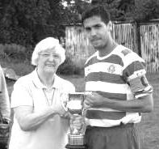
Having now had eight of these occasions it is no longer possible to put everything into a pre-season programme, due to costs. A full detailed account is available at our website which is listed at the foot of every programme page.

However, a quick summary of events shows the following:
2007: Teams: Epsom & Ewell, Banstead Athletic, Corinthian Casuals, Molesey
Final: Banstead Athletic 2-2 Molesey (Banstead won 4-1 on penalties)
Played at Merland Rise, Banstead Athletic F.C.

2008: Teams Epsom & Ewell, Banstead Athletic, Dorking, Molesey
Final: Epsom & Ewell 1-1 Banstead Athletic (Epsom & Ewell won 3-2 on penalties) (see picture right)
Played at Merland Rise, Banstead Athletic F.C.

2009: Teams Epsom & Ewell, Banstead Athletic, Leatherhead, Molesey
Final: Molesey 2-2 Leatherhead (Molesey won 5-4 on penalties)
Played at Merland Rise, Banstead Athletic F.C.

2010: Two teams only: Molesey 1-0 Epsom & Ewell
Played at Goals, Kingston Road, Tolworth

2011: Teams Epsom & Ewell, Bookham, Dorking, Molesey
Final: Bookham 1-0 Dorking
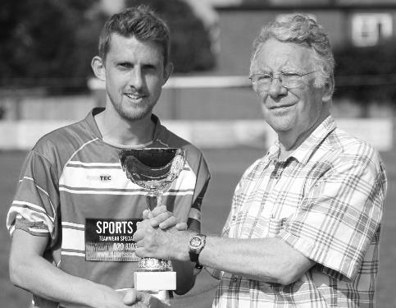
Played at Meadowbank, Dorking F.C.

2012: Two teams only: Chipstead 2-1 Epsom & Ewell
Played at High Road, Chipstead F.C.

2013: Teams Epsom & Ewell, Colliers Wood United, Dorking Wanderers,
Eversley & California
Final: Eversley & California 2-2 Colliers Wood United
(Eversley & C won 7-6 on penalties)
Played at Wibbandune, Colliers Wood United F.C.

2014: Two teams only: Horsham YMCA 2-5 Epsom & Ewell (see picture left)
Played at Gorings Mead, Horsham YMCA F.C.

Cup Recaps 2014/15
EL Records Premier Challenge League Cup
Semi Finals
Colliers Wood United | 5-2+ | Farnham Town
Windsor | 1-2 | Camberley Town
Final @ Woking F.C. – Friday 1st May
Colliers Wood United | 1-2+ | Camberley Town

Surrey Senior Cup
Semi Finals
Molesey | 1-2 | Met Police
Merstham | 4-3 | Ashford Town (Mx)
Final @ Woking F.C. – Wednesday 6th May
Merstham | 0-2 | Met Police

F.A. Vase
Semi Finals – 1st leg - 21st March
Highworth Town | 0-1 | North Shields
AFC St Austell | 0-2 | Glossop North End
Semi Finals – 2nd leg – 28th March
North Shields | 3-0 | Highworth Town
Glossop North End | 0-1 | AFC St Austell
Final @Wembley Stadium – 9th May
North Shields | 2-1+ | Glossop North End
Northern League |  | North West Counties

Club Statistical History - (up to date):
All League: Played: 2,795, Won: 1,140, Drawn: 529, Lost: 1,126
For: 5,124, Against: 4,985, GD: plus 139 - Win Ratio 40.79%

Combined Counties League only: Played: 374, Won: 166, Drawn: 71, Lost: 137
For: 658, Against: 599, GD: plus 59 - Win Ratio 44.39%

Cup and Other: Played: 1,092, Won: 518, Drawn: 127, Lost: 439
For: 2,374, Against: 2,038, GD: plus 336 - Win Ratio 47.44%

Abandoned Matches: Played: 8: For: 14, Against: 16

Under Glyn Mandeville: Played 39, Won: 20, Drawn: 2, Lost: 17
For: 77, Against: 71, GD: plus 6 - Win Ratio 51.28%

Overall Total: Played 3,887, Won: 1,658, Drawn: 656, Lost: 1,565, Abandoned: 8
For: 7,498, Against: 7,023, GD: plus 475 - Win Ratio 42.66%

Match and Ball Sponsorships – 2015/16
Opponent | Date | Match Sponsor | Ball Sponsor
Hoddesdon Town | 18/07/15 | Geoff Dyke
Windsor | 08/08/15
Erith & Belvedere | 16/08/15
Colliers Wood United | 18/08/15 | Provisional - if no F.A. Cup replay
Carshalton Athletic | 30/08/15 | Provisional - Only if we defeat Erith & Belvedere
Raynes Park Vale | 31/08/15 | or 01/09/15 if we defeat Erith & Belvedere and even then, all dependent on not having an F.A. Cup replay
AFC Hayes | 19/09/15
Farnham Town | 26/09/15
Chertsey Town | 17/10/15
Chessington & Hook United | 07/11/15
Hanworth Villa | 21/11/15
Guildford City | 05/12/15
Cove | 08/12/15
Sutton Common Rovers | 19/12/15
Redhill | 02/01/16
Spelthorne Sports | 16/01/16
Hartley Wintney | 30/01/16
Bedfont Sports | 13/02/16
Horley Town | 27/02/16
Knaphill | 12/03/16
Westfield | 26/03/16
Badshot Lea | 09/04/16
Camberley Town | 16/04/16
Ashford Town (Mx) | 30/04/16
For League, League Cup and Surrey Senior Cup Matches:

Match sponsorship - £40.00 Match ball sponsorship - £25.00.
Combined Offer of Match and Match Ball sponsorship for £55.00.

For F.A. Cup and F.A. Vase matches:

Match sponsorship - £50.00 Match ball sponsorship - £30.00.
Combined Offer of Match and Match Ball sponsorship for £65.00.
----------------------------------------------------------------------------------------------------------------------------
Sponsorship includes: (x2 for match, x3 for match and ball)

Admission, programmes, hospitality and advertising and mascot for the day (if required).

If you are interested, just speak to a Committee Member, you know where we are!
Alternatively, drop me an email at: richard.c.lambert@gmail.com

Salts Super Six Predictor
The Salts Super Six Predictor is live again for the first time this season. The tickets are on sale at today’s game to the left of the gate, although the matches are actually to be played on this coming Saturday.

The competition is easy to play and you don’t even have to be at the match! To win, you simply need to predict the results of six matches correctly from the three options, fill in the form and make sure it is back with one of our distributors before the deadline on the ticket. The latest fixtures are shown here.

If you are a club regular, you just need to place your name on the sheet, although if you aren’t, then we’ll need a contact number from you too. We will announce any winners on the website within three working days, so don’t worry, we won’t miss you!

We had a big jackpot winner last year and who knows how much could be won this time! It is currently £50 and you’ll always know the size of the pot before you enter.

Please note that if there is more than one winner, the prize pot would be shared between the winners. All you need to do now is have a go, as many times as you like!

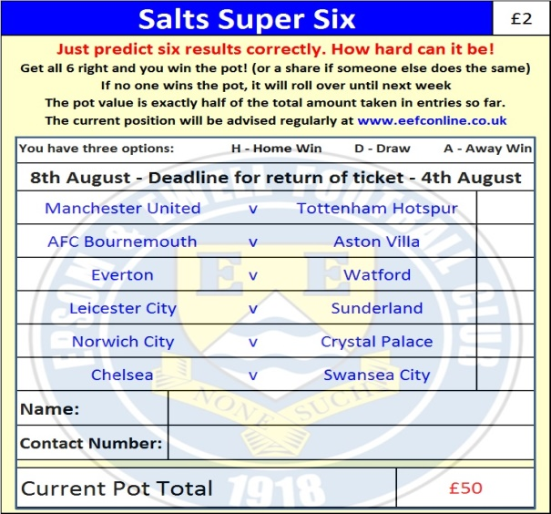

Good luck!

Who is in the cover picture?
From left to right:
Paul Duffell, Dave Wilson, Ian Williams,
Neil Robson, Brian Perkins, Ricky Kidd, John Sears.

How many did you get?

Dave Wilson Trophy IX
Tuesday, 4th August 2015 - Kick-off 7.30 p.m.
Epsom and Ewell  (Royal Blue & White hoops) | V |  | Chipstead  (Green and White)
Squad | NUMBERS
Michael Eacott |  |  | R.Burdbridge
© Sam Currie |  |  | J.Fuller
Matt Tanton |  |  | L.Hamilton
Dale Marvell |  |  | S.Betancourt
James Taylor |  |  | S.Preddie
Dan Dean |  |  | A.Panayi
Matt Farrell |  |  | R.Webbe
Reisse Griffin |  |  | B.Chick
Kyle Hough |  |  | T.Pink
Daryl Cooper-Smith |  |  | K.Kedze
Matt Ferdinando |  |  | F.Ogeah
Craig Hastings |  |  | S.Ibizuge
Beckett Oliver |  |  | D.Tunde
Jakub Kurdziel |  |  | M.Belli
Rhys North |  |  | J.Brady
Savva ‘Agi’ Panayiotou |  |  | C.Murray-Price
Alex McKay
Ali Dewar
Glyn Mandeville | MANAGER |  | S.Colbran
Matt Smith | ASSISTANT |  | S.Funnell
Steve Eacott / Alex McKay | COACHES |  | T.Stone / M.Fuller
REFEREE: Nick Clarke
ASSISTANTS: Iain Bryant, Tim Gilmore
Sponsorships for any match, player or
match ball are being collected now.
Speak to a Committee Member for details

OUR FIRST LEAGUE VISITORS TO HIGH ROAD
Windsor
Saturday 8th August 2015 - Kick-off 3.00 p.m.
Combined Counties League – Premier Division

